dSTORM on-a-chip - Sample Preparation

# Protocol for best coupling

* Best NA 0.4-0.5
* From simulations: If NA is too large, low incoupling efficiency, due to…?
* 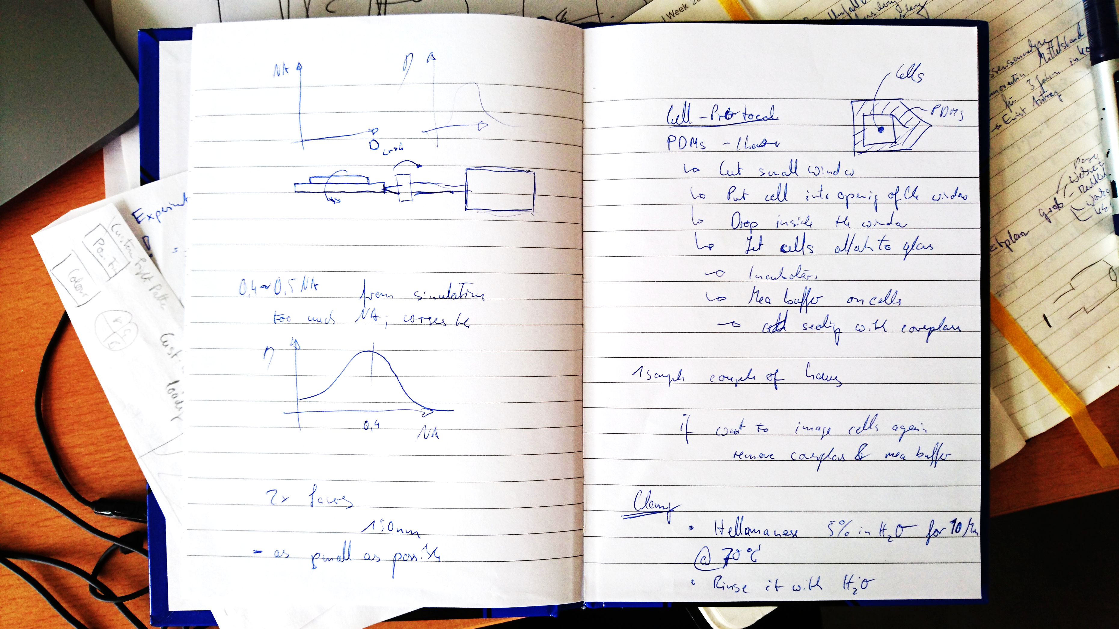
* If Laser intensity is too small => Use too lasers from both sides
* Use smallest Light-Guide that is possible, otherwise Intensity drops down
* Observe the speckle/diffraction pattern behind the Chip (How should it look like? )
* Tilting and shifting the lens is not such a serious problem, but keep variations low!
* 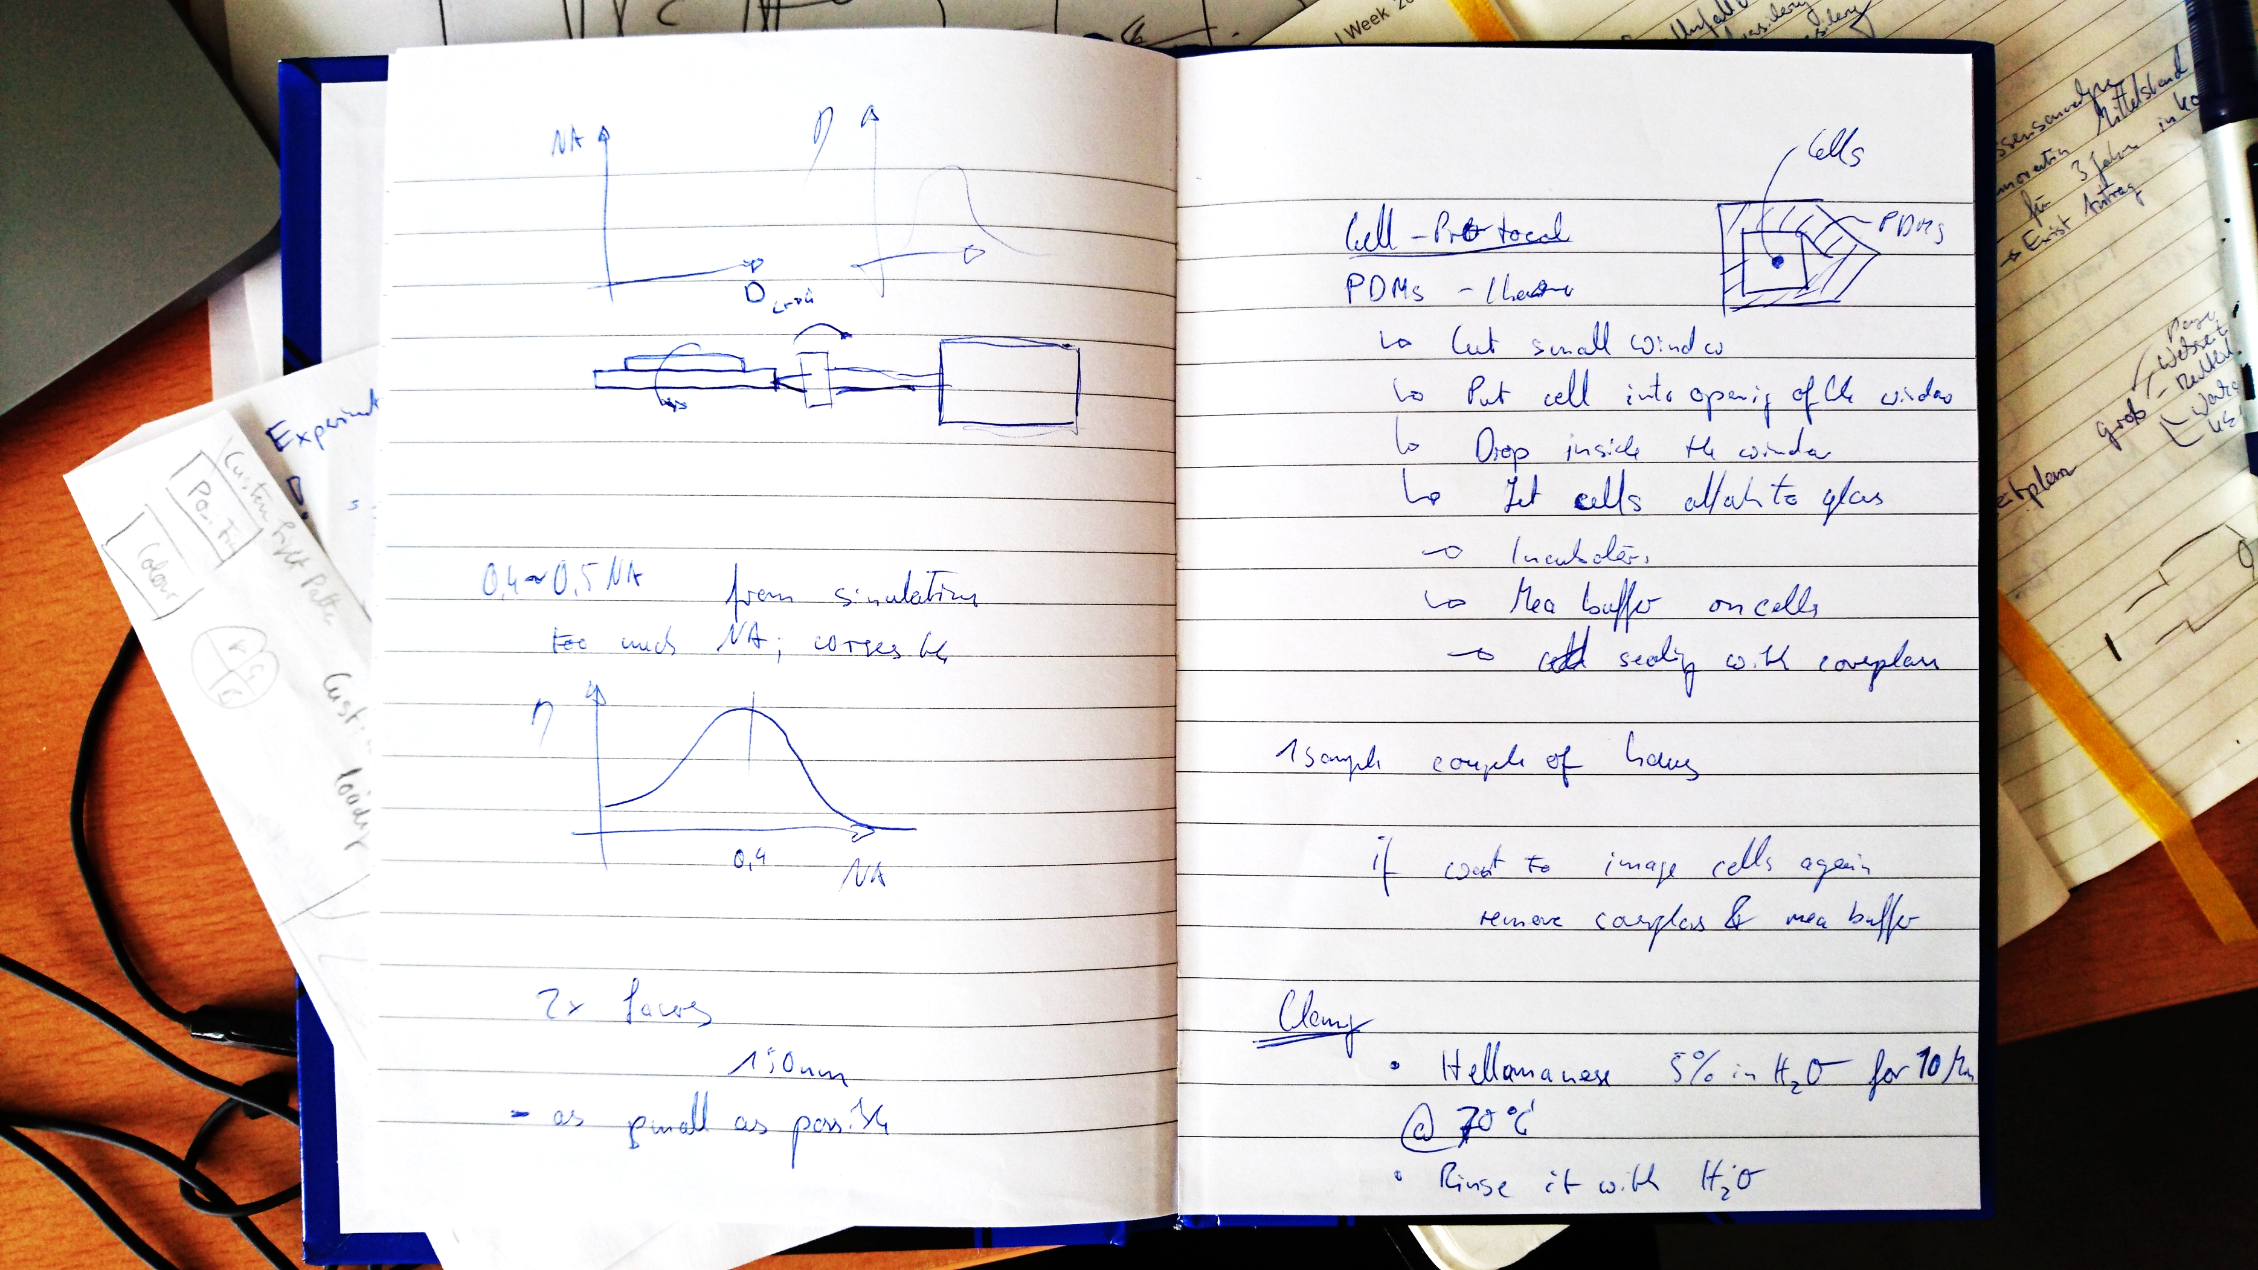
* Chip – (tilted/misaligned) coupling lens – Laser

# Sample preparation - Protocol

* Prepare the PDMS chamber (Cut with knife from Petri Dish)
* Cut small window
* 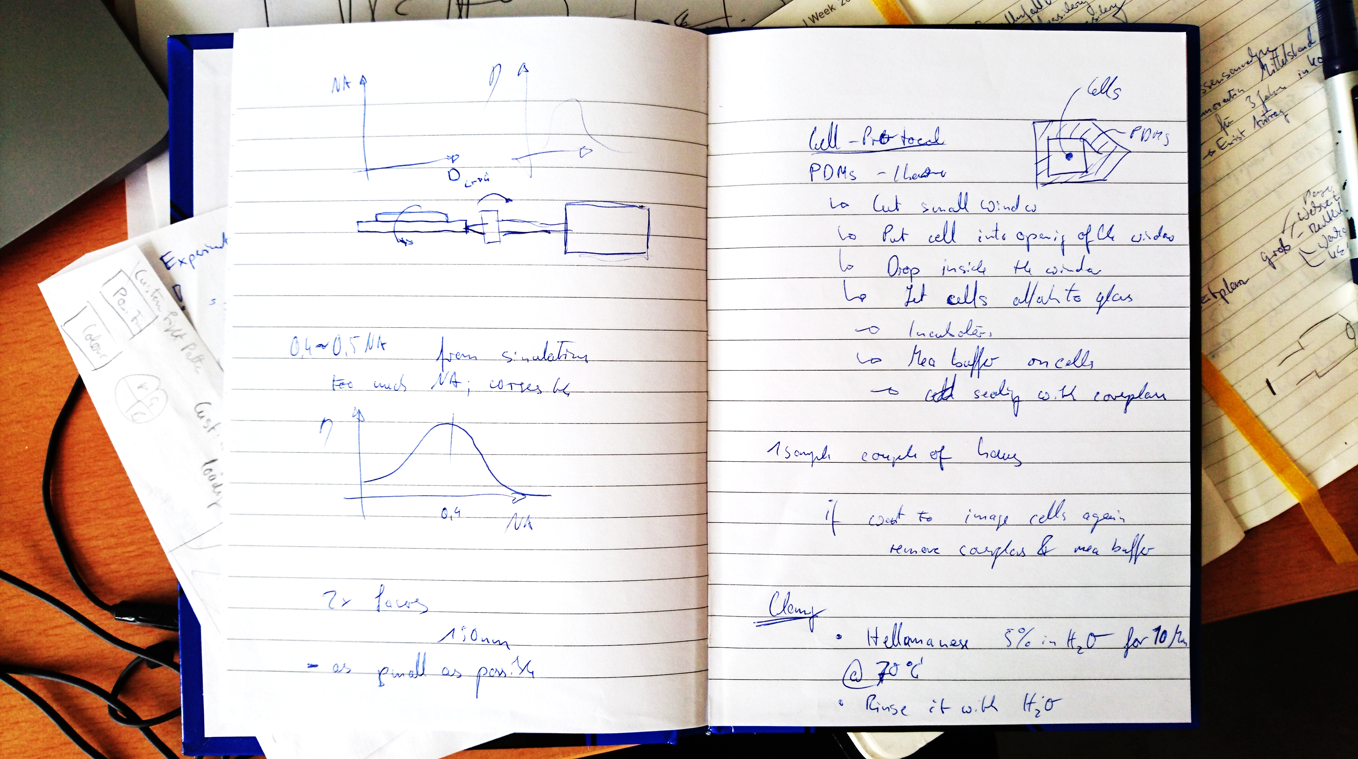
* Put cell into opening of the window (Small Drop inside the window that roughly fills the volume of the chamber; don’t put too much fluid into the volume!)
* Let cells attach to the glass
* But the chip into the incubator
* Let it grow!
* Apply MEA Buffer on the cells
* Seal it with coverglass
* 1 Sample can last for couple of hours!
  + If you want to image the cells again, remove coverglass (tricky, it can break!) and apply some more MEA buffer

# Clean the Chip – Protocol

* Put the chip in a solution of Hellamanex 5% in H2O for 10 Minutes @ 70°C
* Rinse with H20
* Rinse with Ethanol
* Rinse with H20 Blow with Prpanol

# Tips and Tricks – Protocol

* Use Alexa 647 dye and put it on the chip – without any cells
* Observe the Blinking
* HeLa-cells don’t work well
* The flatter the cells the better!

# Excerpt from Chip-based wide field-of-view nanoscopy

Robin Diekmann1†et al

Sample preparation. Sprague–Dawley male rats (Scanbur) were kept under

standard conditions and fed standard chow ad libitum (Scanbur). The experimental

protocols were approved by the Norwegian National Animal Research Authority

(NARA) in accordance with the Norwegian Animal Experimental and Scientific

Purposes Act of 1986. The rats (body weight 150–300 g) were anaesthetized with a

mixture of medetomidin (Domitor vet, Orion) and ketamine (Ketalar, Pfizer) and

LSECs were isolated and purified as described in ref. 36. Cleaned waveguide chips

were coated with human fibronectin (50 μg ml–1) for 10 min at room temperature.

Isolated LSECs in RPMI 1640 were seeded on the fibronectin-coated waveguide

chips and incubated for 1 h at 37 °C, followed by a washing step to remove

non-attached cells and debris, and allowed to spread their cytoplasm for another 2 h.

The cells were then washed with phosphate buffered saline (PBS) and fixed with 4%

paraformaldehyde (PFA) in PBS and 0.02 M sucrose, pH 7.2 for 30 min. Following

fixation, the cell membranes were permeabilized with 0.1% Triton X in PBS for

10 min at room temperature (RT). Actin was stained with Atto 488-phalloidin

(Sigma Aldrich), at 1:400 dilution in PBS, by 20 min incubation at RT. Membranes

were stained with CellMask Deep Red (Life Technologies), at 1:1,000 dilution in PBS,

by 10 min incubation at RT. Tubulin was either stained with 1:400 α-tubulin

antibody, Alexa Fluor 488 (ThermoFisher Scientific), at 1:400 dilution in PBS

containing 5% bovine serum albumin, fraction V (AppliChem), by 20 min

incubation at RT, or with mouse anti β-tubulin (Sigma Aldrich), at 1:400 dilution

in PBS/BSA, for 1 h at RT, followed by goat anti mouse Alexa Fluor 647

(ThermoFisher Scientific) at the same concentration as the primary antibody,

for 1 h at RT.

Dye surfaces were prepared by submerging ∼50 nM Alexa 647 in 0.05%

poly-L-lysine (Sigma Aldrich) and incubating it for ∼20 min on the waveguide chip

or coverglass followed by an optional washing step. For measurements of the

achievable localization precision using high- and low-NA objective lenses on the

inverted conventional set-up, 200 nm TetraSpeck Microspheres (Thermo Fisher

Scientific) were diluted ∼1:50 in Vectashield H-1000 (Vector Laboratories).

Alexa 647-labelled R50 nanorulers (Gattaquant) were prepared on the waveguide

by placing a polydimethylsiloxane (PDMS) chamber on the surface, washing it three

times with PBS, incubating it with 0.5 mg ml–1 BSA-biotin (Sigma Aldrich) in PBS

for 5 min, incubating it with 0.5 mg ml–1 neutravidin (VWR) in PBS for 5 min, and

incubating it with 0.5 μl R50 stock solution in 10 μl 60 mM MgCl2 in PBS for 5 min.

Each step, beginning from the BSA-biotin incubation, was followed by washing two

or three times with 60 mM MgCl2 in PBS. For imaging on the conventional inverted

set-up, the sample was prepared on a coverglass (#1.5) (Thermo Fisher Scientific

Gerhard Menzel) by placing a PDMS chamber on the surface, washing it three times

with PBS, incubating it with 5 mg ml–1 BSA-biotin (Sigma Aldrich) in PBS for

5 min, washing it three times with PBS, incubating it with 0.5 mg ml–1 neutravidin

(Thermo Fisher Scientific) in PBS for 10 min and incubating it with 2.5 μl R50 stock

solution in 25 μl 10 mM MgCl2 in PBS for 1 h. Each step, beginning from the

neutravidin incubation, was followed by washing three times with 10 mM

MgCl2 in PBS.

Imaging buffer was prepared by mixing 22.5 μl H2O-based oxygen scavenger

system solution (based on glucose oxidase (Sigma-Aldrich) and catalase

(Sigma-Aldrich))52 with 30 μl PBS. The buffer was supplemented with 2 mM

cyclooctatetraene (COT) (Sigma Aldrich) in the case of Alexa 647 imaging and with

different concentrations of mercaptoethylamine (MEA) (Sigma Aldrich). An MEA

concentration of 95 mM was used in the case of CellMask Deep Red, Alexa 488 and

Atto 488 imaging, which we found to yield good blinking behaviour on the

waveguide. In the case of all Alexa 647 imaging experiments on the waveguide, we

used an MEA concentration of 20 mM. The buffer for Alexa 647-labelled DNA

nanorulers on the conventional inverted microscope was prepared from D2O-based

components, supplemented with 45 mM Tris, and contained MEA at a

concentration of 10 mM. The same MEA concentration with additional 2 mM COT

was used in H2O-based buffer to record the example raw dSTORM data on the

conventional inverted set-up. Sub-diffraction-sized, fluorescent 100 nm TetraSpeck

microspheres (Life Technologies) at a low concentration (∼1:5,000 from stock) were

used to aid algorithmic drift correction of super-resolved images.

To prevent light from coupling into the coverslip, we mounted a custom-made

PDMS chamber of 120 μm height on top of the chip to lift the coverglass (#1.5)

(Thermo Fisher Scientific Gerhard Menzel), except for the experiment shown in

Fig. 5 and Supplementary Fig. 17. It was verified that only light guided by the

waveguide excites fluorescence (Supplementary Fig. 5 and Supplementary Movie 1).

The chamber also served as a vessel for the imaging buffer. Alternatively, the buffer

was held by capillary action between the chip and the coverslip directly deposited on

the waveguide. In the latter case, a small piece of black PDMS of significantly greater

height (∼2 mm) was applied close to the input facet to block any unguided light

before the coverslip (see experimental results in Fig. 5 and Supplementary Fig. 17).

This PDMS was manufactured such that a thin layer touching the waveguide was

transparent, to prevent light absorption by the black PDMS